[E145] Battery

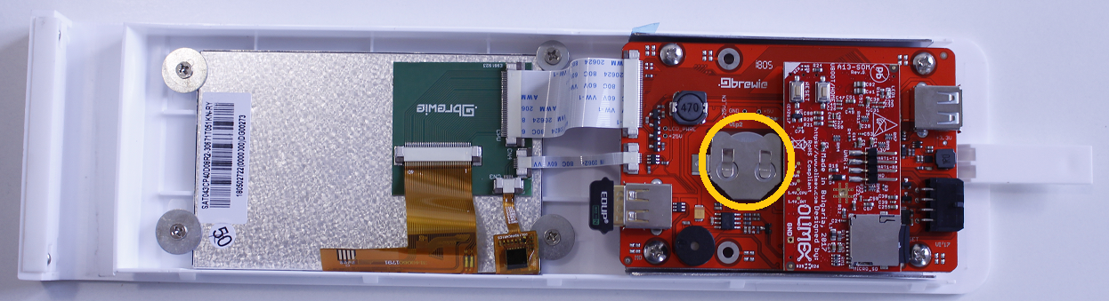

The battery is located in the front panel assembly inserted in the socket of ARM panel.

Check [E119] about how to remove the front panel from the B+.

To remove and replace the battery use a screwdriver and push it out from its socket. To replace it use a CR2032 type button battery.

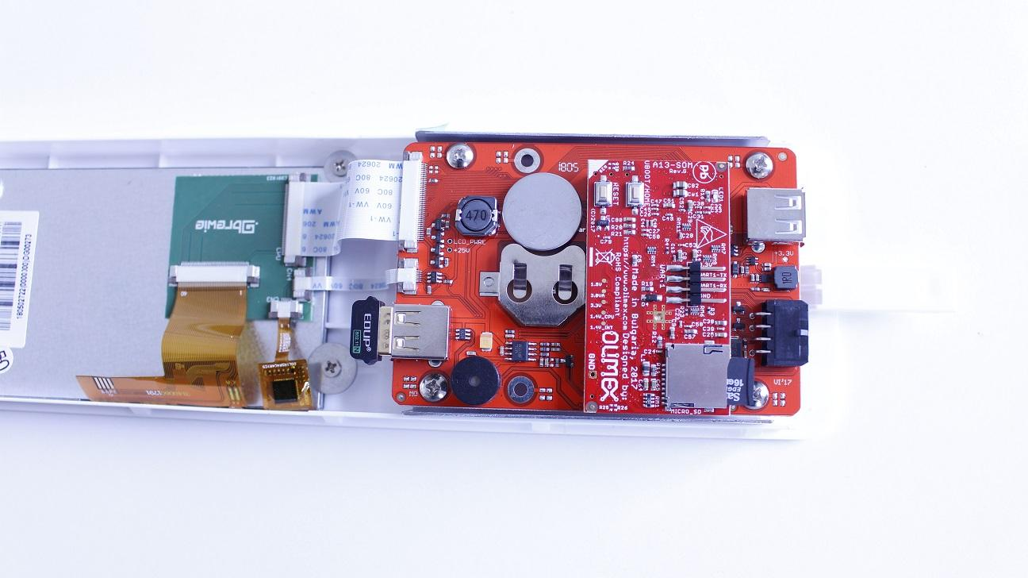

Reassemble consists of the same steps in reverse.